**Project Part 2**

Convolution Neural Network

A**rijit Panda**

**1217155056**

30th April 2020

## Introduction

## Convolution neural network is generally used for the analysis of images. It can assign importance to various aspects in the image and can differentiate between images. CNN makes use of a mathematical operation called convolution, which is a specialized king of linear operations. Some basic layers native to CNN models are convolution layer, pooling layers, and normalization layers. Logically speaking, there are some feature maps for each convolution layer, which extracts very basic design in the images such as corners, lines, shapes, etc. As the layer goes deep, these simple designs combine within themselves to form a complex image. This basic idea, which is also used in drawing, is the reason why CNN works so superbly for image recognition and analysis. There has been tremendous growth in the design of CNN, but for this project, we adhere to very simple designs to classify handwritten digits from the MNIST dataset. hyper parameters values and the training and testing accuracy and loss reported for each.

## The MNIST dataset was used for this project which contains various images of handwritten digits from 0-9. For training of each model, around 60000 images of all digits were used, while for testing, around 10,000 digits were used. The images were all reshaped to a fixed size of 28*28 which helped to maintain consistency in the model. To implement, train and evaluate model, Keras library is used. Keras is a very famous deep learning library, which is famous for experimenting with different models and is very readable and easy to use. In this project, all the work was done with Keras. And to the plot, the graph with train and test, accuracies and losses, matplotlib was used.

## Models and Results

**Model 1:**

**Configuration**

## Convolution layer with 6 feature maps, stride 1 and kernel size of (3, 3)

## Max pooling layer of size 2*2 with stride 1

## Convolution layer with 16 feature maps, stride 1 and kernel size of (3, 3)

## Max pooling layer of size 2*2 with stride 1

## Fully connected layer with 120 nodes and relu as the activation function

## Fully connected layer with 84 nodes and relu as the activation function

## Softmax layer with 10 output nodes, corresponding to each output

**Results:**

Test loss: 0.06917221449492499

Test accuracy: 0.9779000282287598

Accuracy vs epoch and model loss vs epoch plots

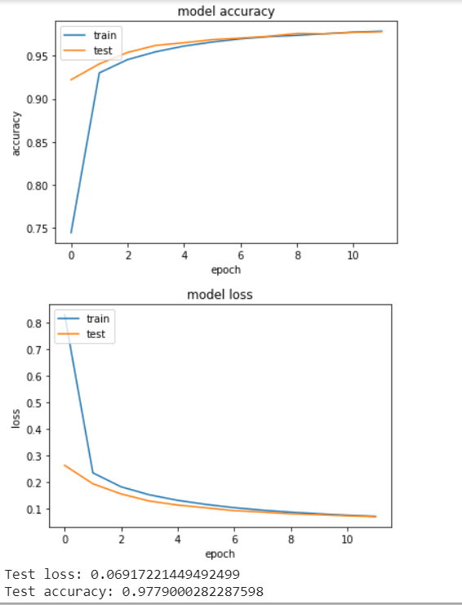

**Model 2:**

**Configuration**

## Convolution layer with 6 feature maps, stride 1 and kernel size of (5, 5)

## Max pooling layer of size 2*2 with stride 1

## Convolution layer with 16 feature maps, stride 1 and kernel size of (5, 5)

## Max pooling layer of size 2*2 with stride 1

## Fully connected layer with 120 nodes and relu as the activation function

## Fully connected layer with 84 nodes and relu as the activation function

## Softmax layer with 10 output nodes, corresponding to each output

**Results:**

Test loss: 0.06141008994122967

Test accuracy: 0.98089998960495

Accuracy vs epoch and model loss vs epoch plots

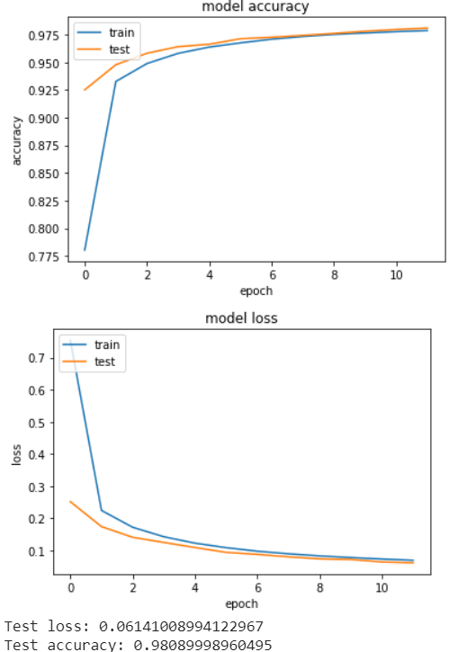

**Model 3:**

**Parameters**

## Convolution layer with 10 feature maps, stride 1 and kernel size of (5, 5)

## Max pooling layer of size 2*2 with stride 1

## Convolution layer with 22 feature maps, stride 1 and kernel size of (5, 5)

## Max pooling layer of size 2*2 with stride 1

## Fully connected layer with 120 nodes and relu as the activation function

## Fully connected layer with 84 nodes and relu as the activation function

## Softmax layer with 10 output nodes, corresponding to each output

**Results:**

Test loss: 0.0564347909626551

Test accuracy: 0.9811999797821045

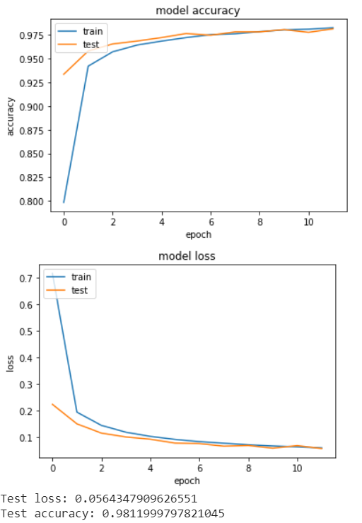

**Conclusion**

Convolutional Neural Network works comparatively other machine learning algorithms for classification of images. The accuracy reported in these simple CNN models is around 0.98 or 98% which indicates its of its efficiency. With bigger networks and the addition of normalization layers, the accuracy can even increase. Given the requirements, we can successfully verify the effectiveness of CNN.